What is single threaded execution?

Single threaded processes **contain the execution of instructions in a single sequence**. In other words, one command is processed at a time. ... These processes allow the execution of multiple parts of a program at the same time. These are lightweight processes available within the process.

What are single thread applications?

[[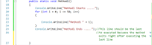](https://www.google.com/search?rlz=1C1CHZL_enIN777IN777&sxsrf=APq-WBub3Yp1CIcjV6u7xrC1cyEUSMvnfw:1646909369595&q=What+are+single+thread+applications?&tbm=isch&source=iu&ictx=1&vet=1&fir=ZJsBvaPaQqWFWM%2CZGc1jBknn9vWFM%2C_&usg=AI4_-kSjjlr9gK-DFnUJLp_Eaeb0wYmvMw&sa=X&ved=2ahUKEwiK8MG_r7v2AhUJxTgGHac5BbUQ9QF6BAgIEAE#imgrc=ZJsBvaPaQqWFWM)](https://www.google.com/search?rlz=1C1CHZL_enIN777IN777&sxsrf=APq-WBub3Yp1CIcjV6u7xrC1cyEUSMvnfw:1646909369595&q=What+are+single+thread+applications?&tbm=isch&source=iu&ictx=1&vet=1&fir=ZJsBvaPaQqWFWM%252CZGc1jBknn9vWFM%252C_&usg=AI4_-kSjjlr9gK-DFnUJLp_Eaeb0wYmvMw&sa=X&ved=2ahUKEwiK8MG_r7v2AhUJxTgGHac5BbUQ9QF6BAgIEAE" \l "imgrc=ZJsBvaPaQqWFWM)

A single threaded application **includes only one thread which responsible for executing every task and method, one after the other, and the controller doesn't move to the next task until the previous one ends**. More to that, the main thread doesn't exist until all the tasks are done executing.

**Why JavaScript is a single-thread language that can be non-blocking ?**



The JavaScript within a chrome browser is implemented by V8 engine.

**The V8 engine has two parts:**

1. Memory Heap
2. Call Stack

**Memory Heap:** It is used to allocate the memory used by your JavaScript program. Remember memory heap is not the same as the heap data structures, they are totally different. It is the free space inside your OS.

**Call Stack:** Within the call stack, your JS code is read and gets executed line by line.

Now, JavaScript is a single-threaded language, which means it has only one call stack that is used to execute the program. The call stack is the same as the stack data structure that you might read in Data structures. As we know stacks are FILO that is First In Last Out. Similarly, within the call stack, whenever a line of code gets inside the call stack it gets executed and move out of the stack. In this way, JavaScript is a single-thread language because of only one call stack.

JavaScript is a single-threaded language because while running code on a single thread, it can be really easy to implement as we don’t have to deal with the complicated scenarios that arise in the multi-threaded environment like deadlock.

Since, JavaScript is a single-threaded language, it is synchronous in nature. Now, you will wonder that you have used async calls in JavaScript so is it possible then?

So, let me explain to you the concept of async call within JavaScript and how it is possible with single-threaded language. Before explaining it you let’s discuss briefly why we require the async call or asynchronous calls. As we know within the synchronous calls, all the work is done line by line i.e. first one task is executed then the second task is executed, no matter how much time one task will take. This arises the problem of time wastage as well as resource wastage. These two problems are overcome by asynchronous calls, where one doesn’t wait for the one call to complete instead it runs another task simultaneously. So, when we have to do things like image processing or making requests over the network like API calls, we use async calls.

Now, coming back to the previous question of how to use async call within JS. Within JS we have a lexical environment, syntax parser, an execution context (memory heap and call stack) that is used to execute the JS code. But except these browsers also have Event Loops, Callback queue, and WebAPIs that is also used to run the JS code. Although these are not part of JS it also helps to execute the JS properly as we sometimes used the browser functions within the JS.

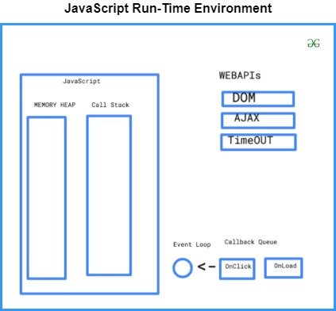

As you can see in the above diagram, DOM, AJAX, and Timeout are not actually part of JavaScript but the part of RunTime Environment or browser, so these can be run asynchronously within the WebAPI using the callback queue and again put in the call stack using event loop to execute.

Let us take an example to be very clear of the concept. Suppose we have the following piece of code that we want to execute in the JS run-time environment.

**Example:**

|  |
| --- |
| <script>   console.log('A');     setTimeout(() => {      console.log('B');     }, 3000);     console.log('C');  </script> |

**Output:**

A C B

Let’s see why this happens as JavaScript is a single-threaded language so, the output should be **A B C**but it is not.

When JS tries to execute the above program, it places the first statement in the call stack which gets executed and prints A in the console and it gets to pop out of the stack. Now, it places the second statement in the call stack and when it tries to execute the statement, it finds out that setTimeout() doesn’t belong to JS so it pops out the function and puts in the WebAPI to get executed there. Since the call stack is now again empty, it places the third statement in the stack and executes it thus prints C in the console.

In the meanwhile, the WebAPI executes the timeout function and places the code in the callback queue. The eventloop checks if the call stack is empty or not or whether there is any statement in the callback queue that needs to be executed all the time. As soon as the event loop checks that the call stack is empty and there is something in the callback queue that needs to be executed, it places the statement in the call stack and the call stack executes the statement and prints B in the console of the browser.

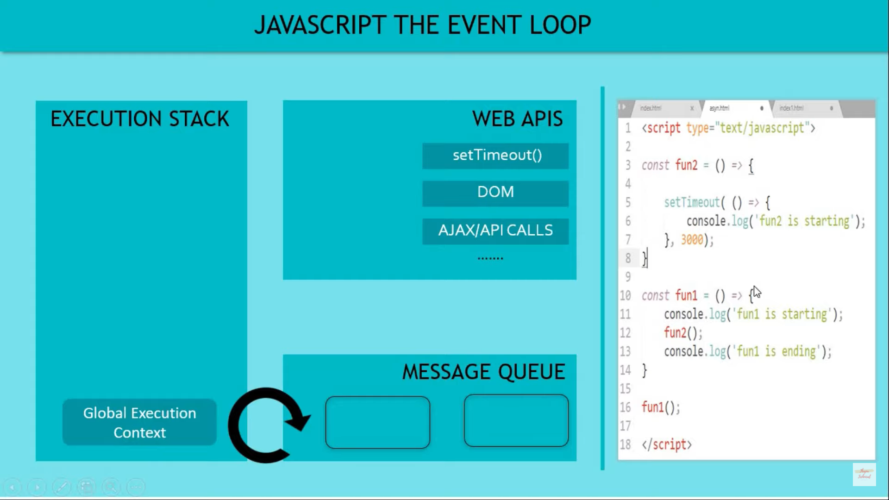

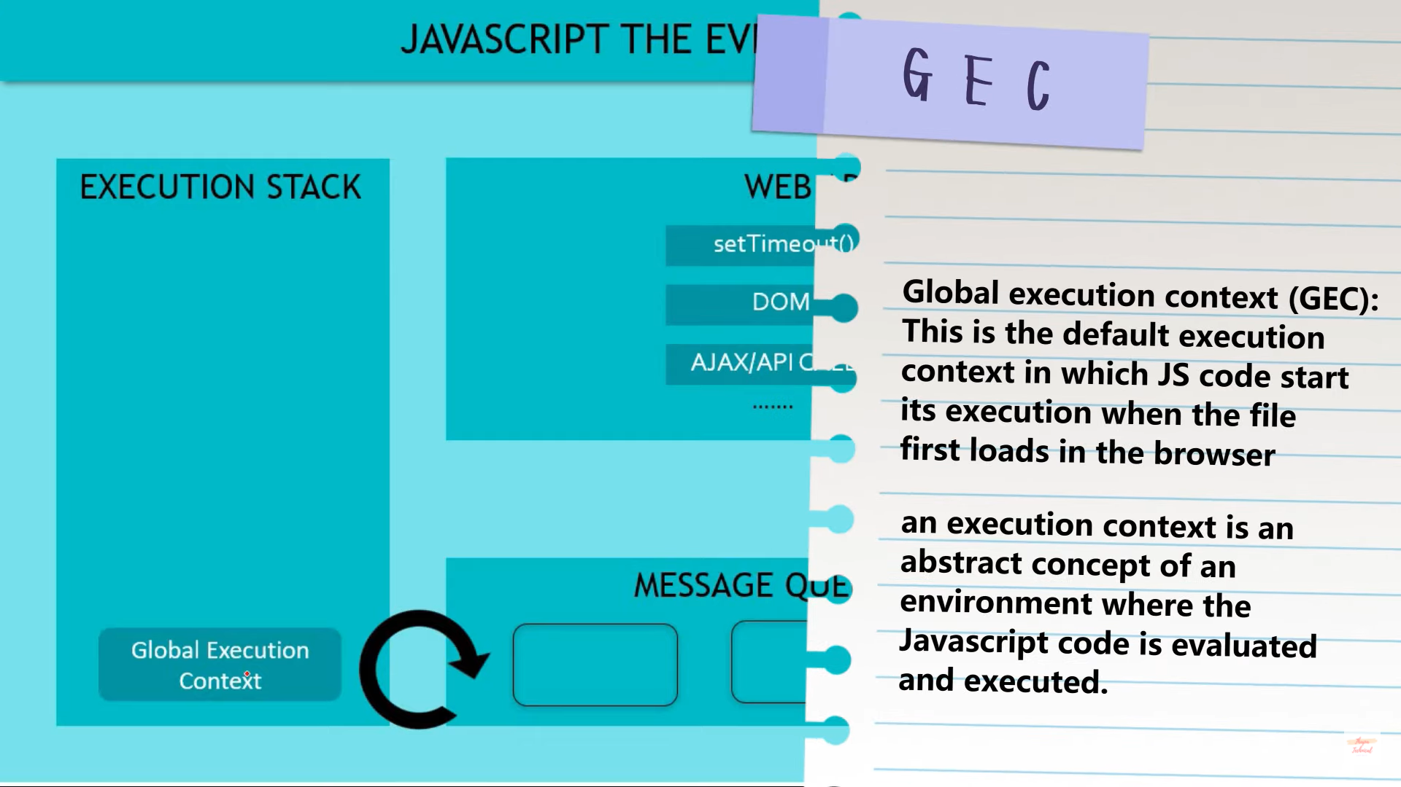

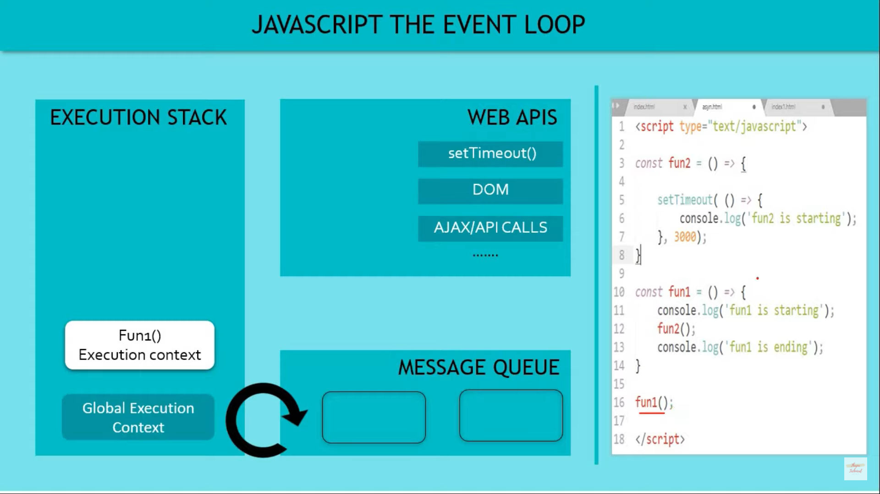

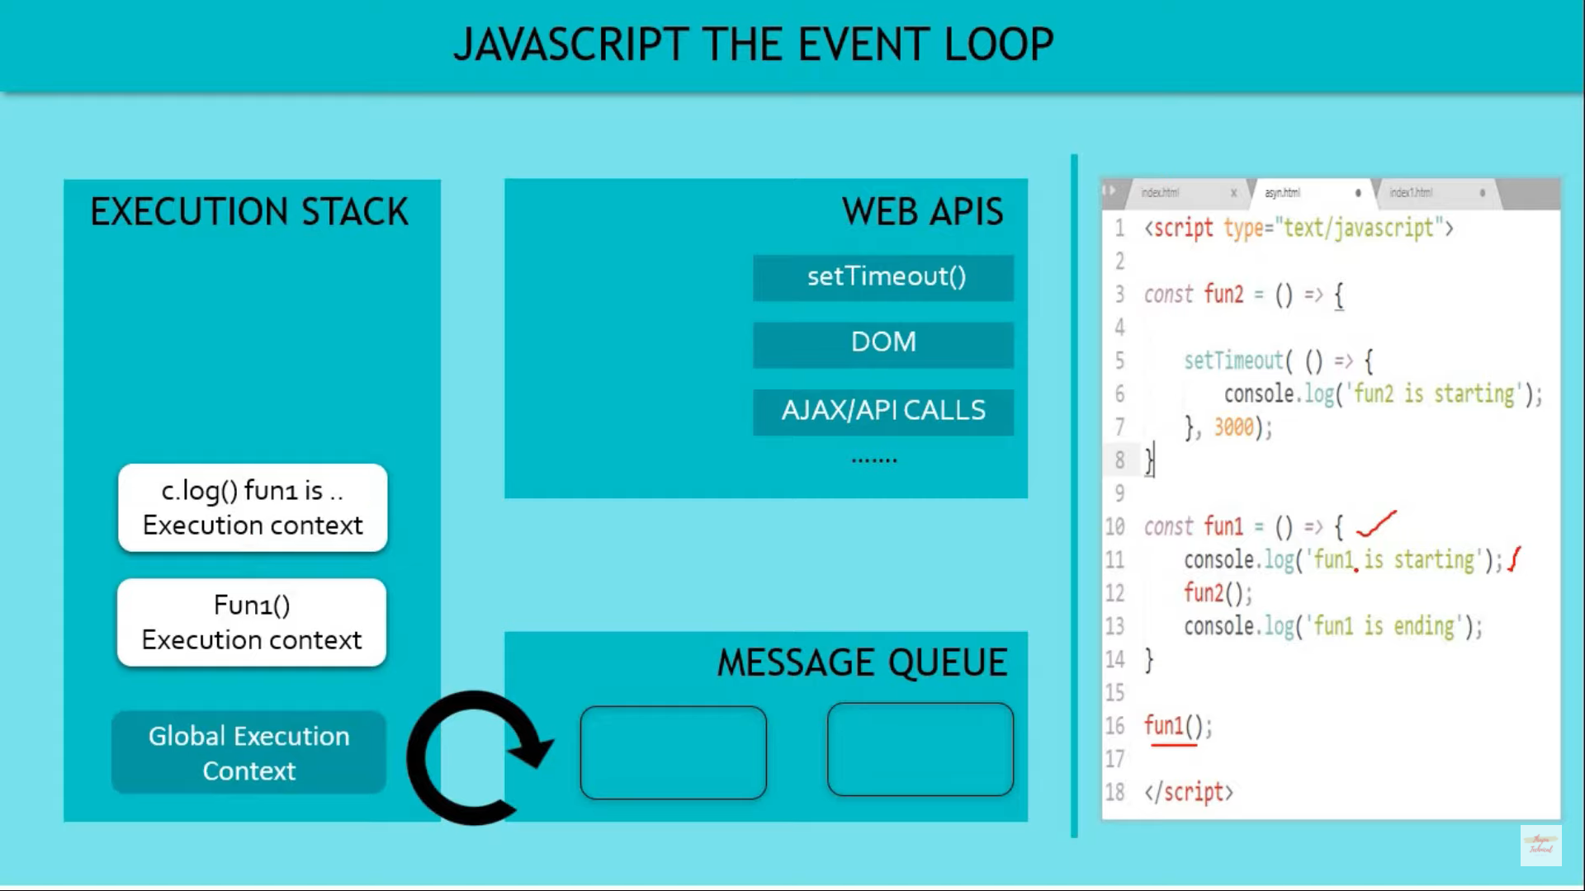

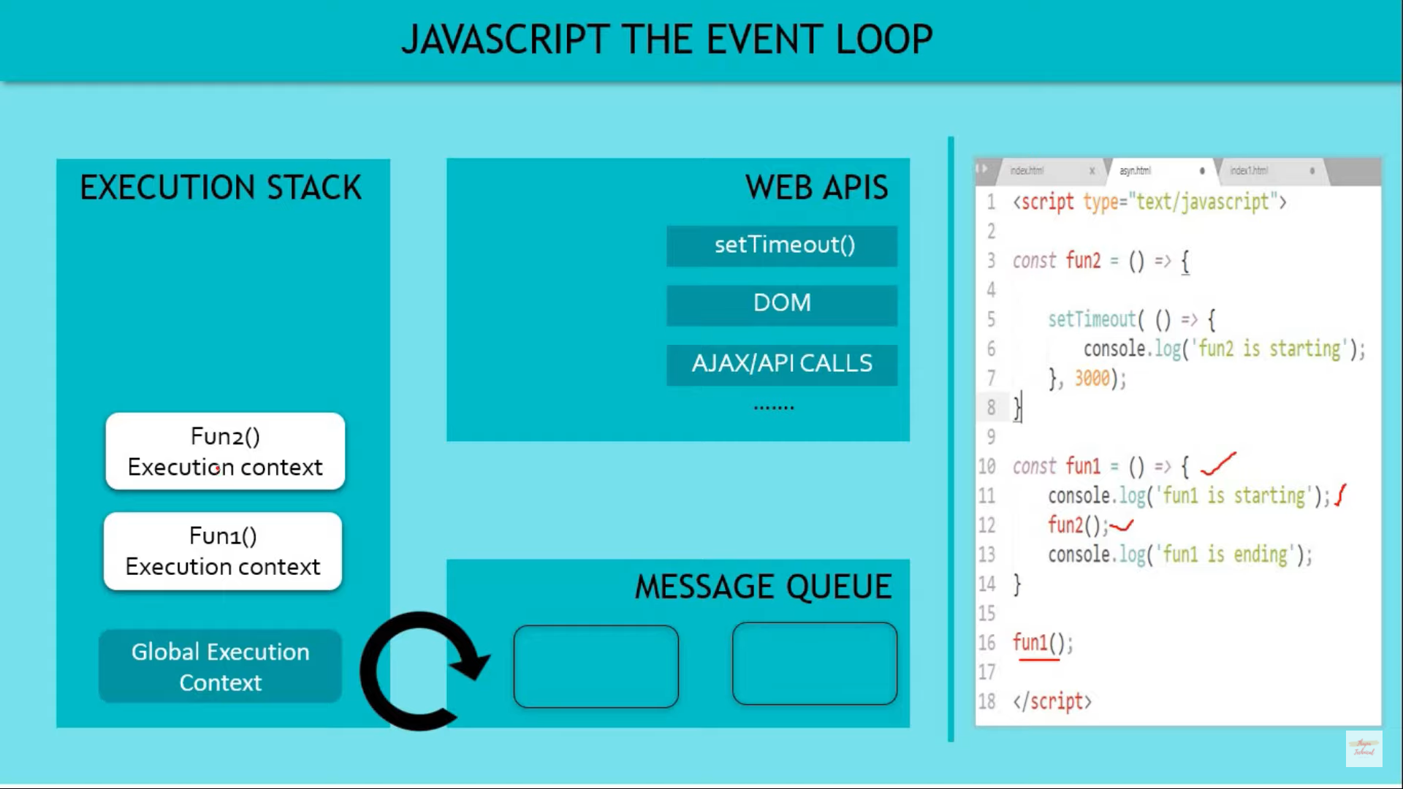

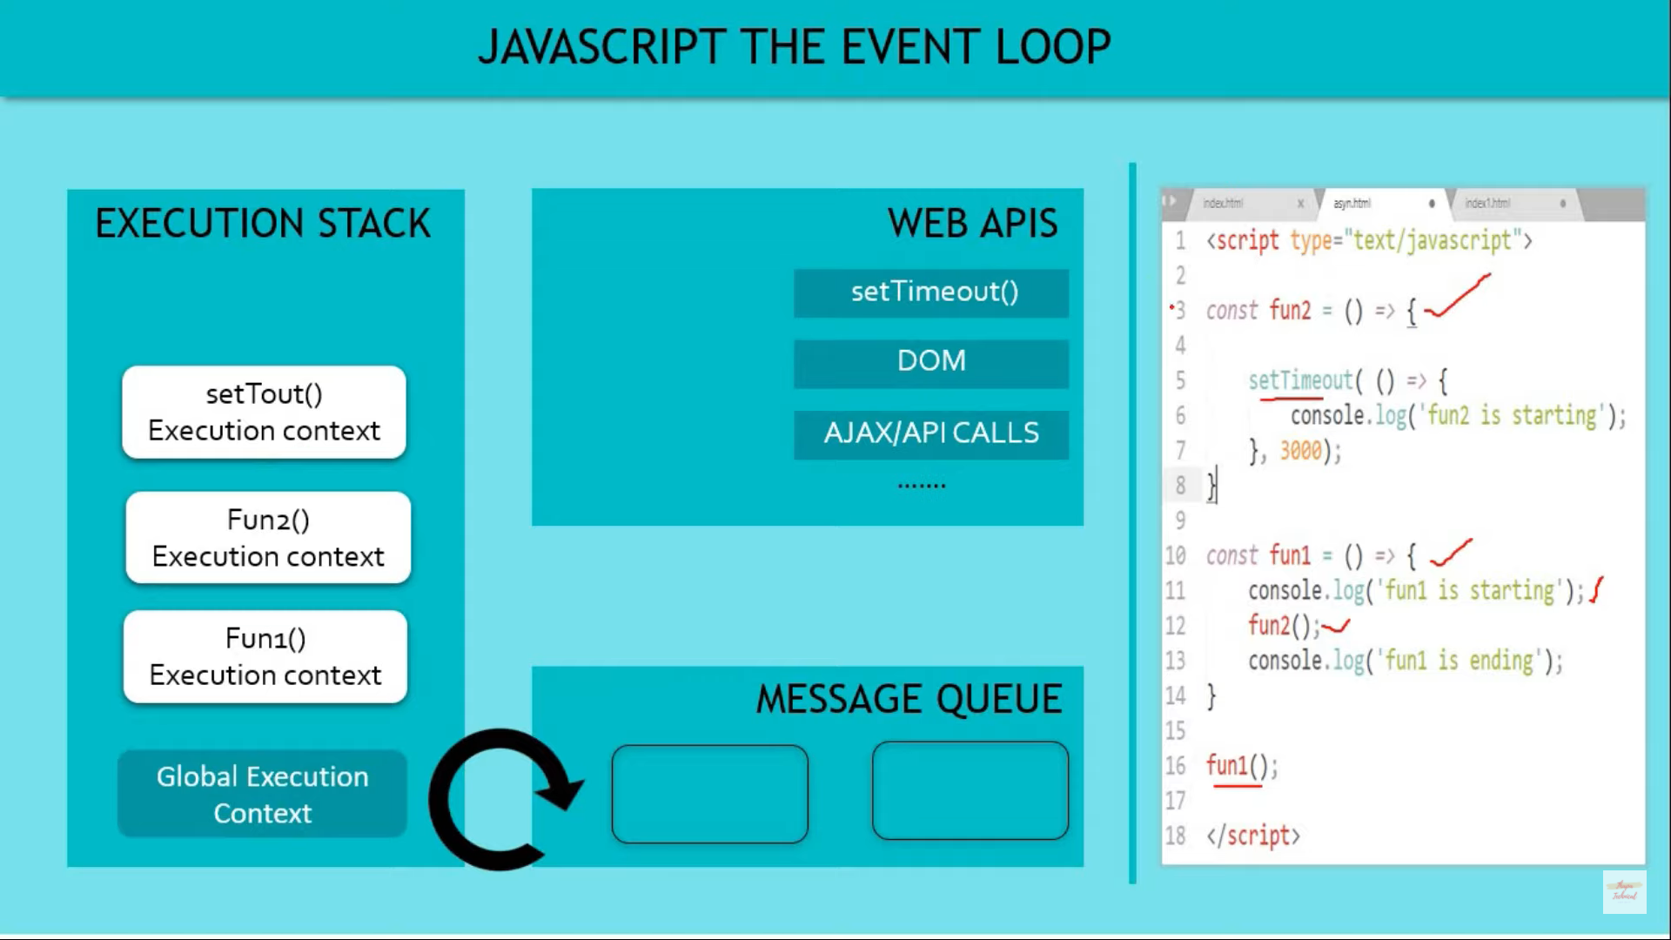

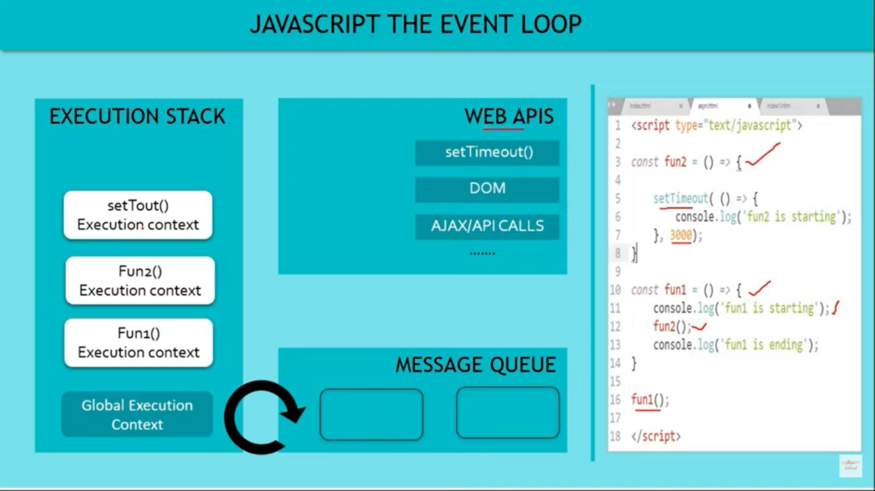

setTimeOut is in Web Api

Its not in JS Engine . We are able to access it coz of Javascript run time

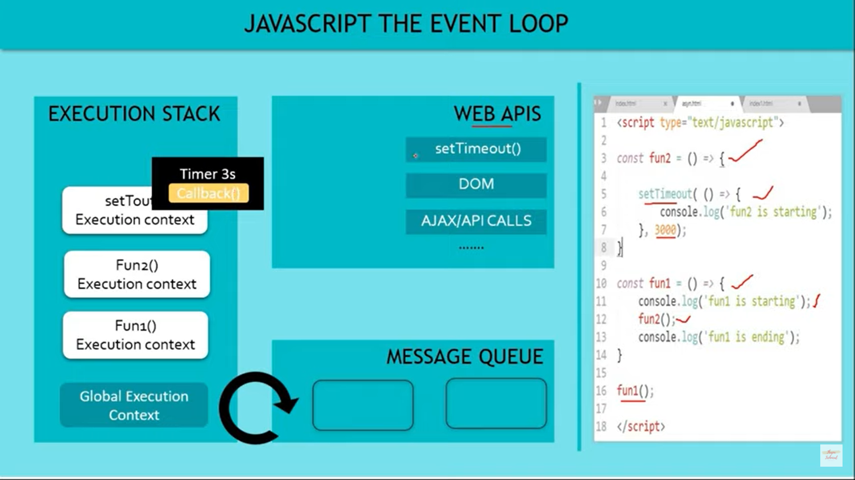

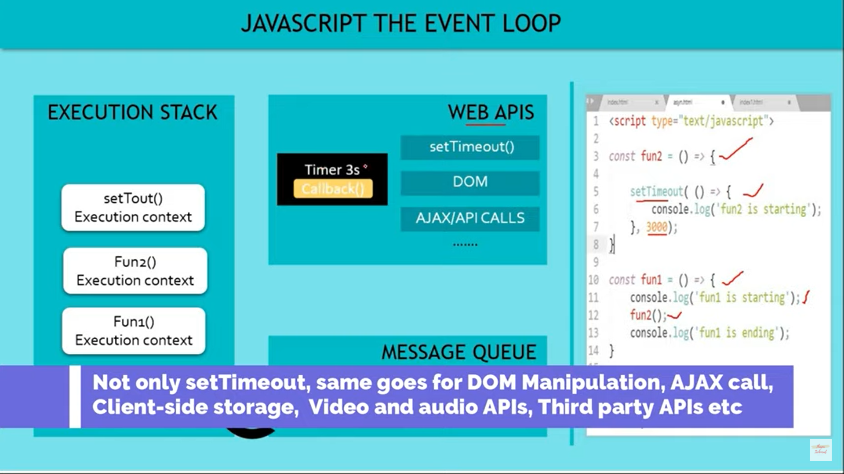

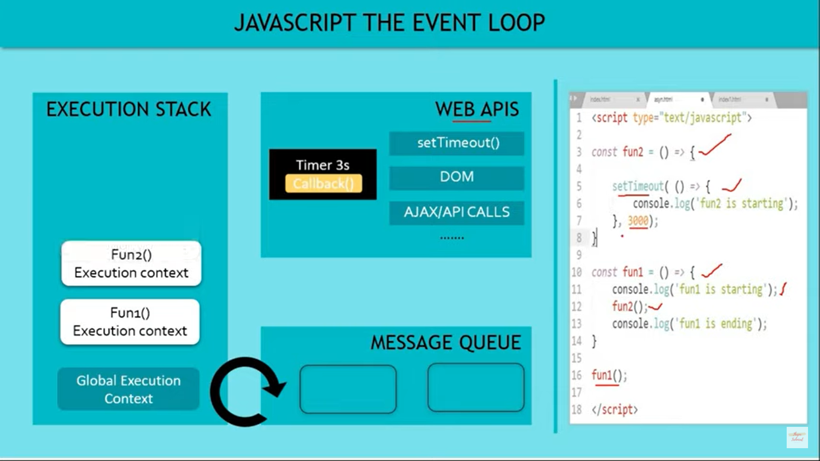

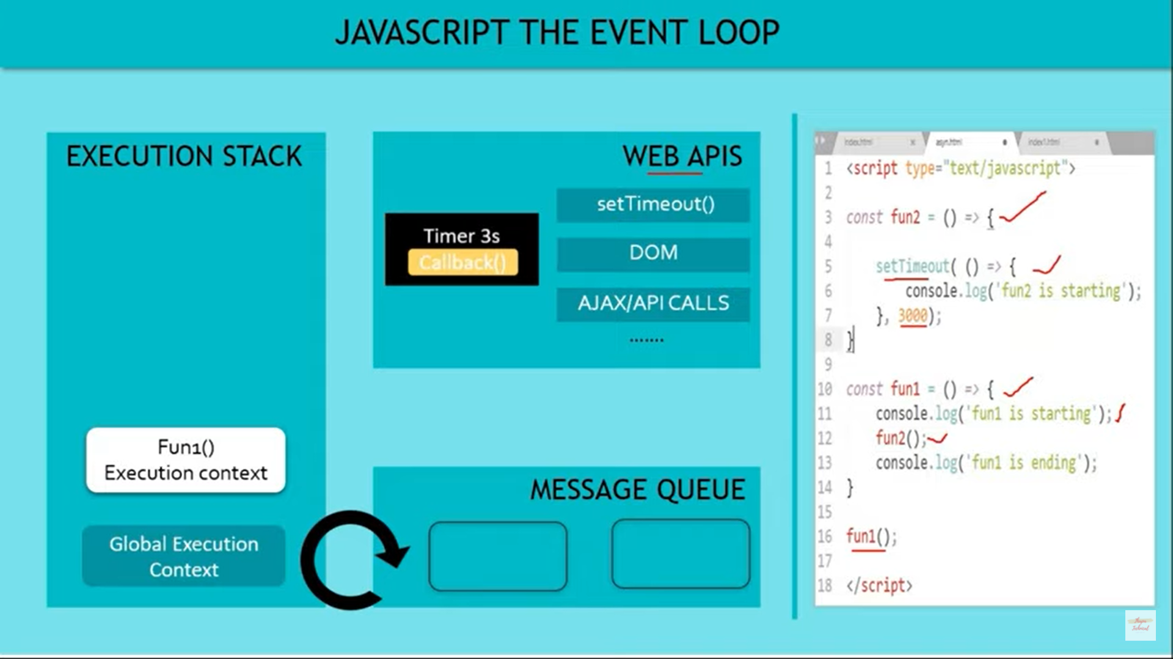

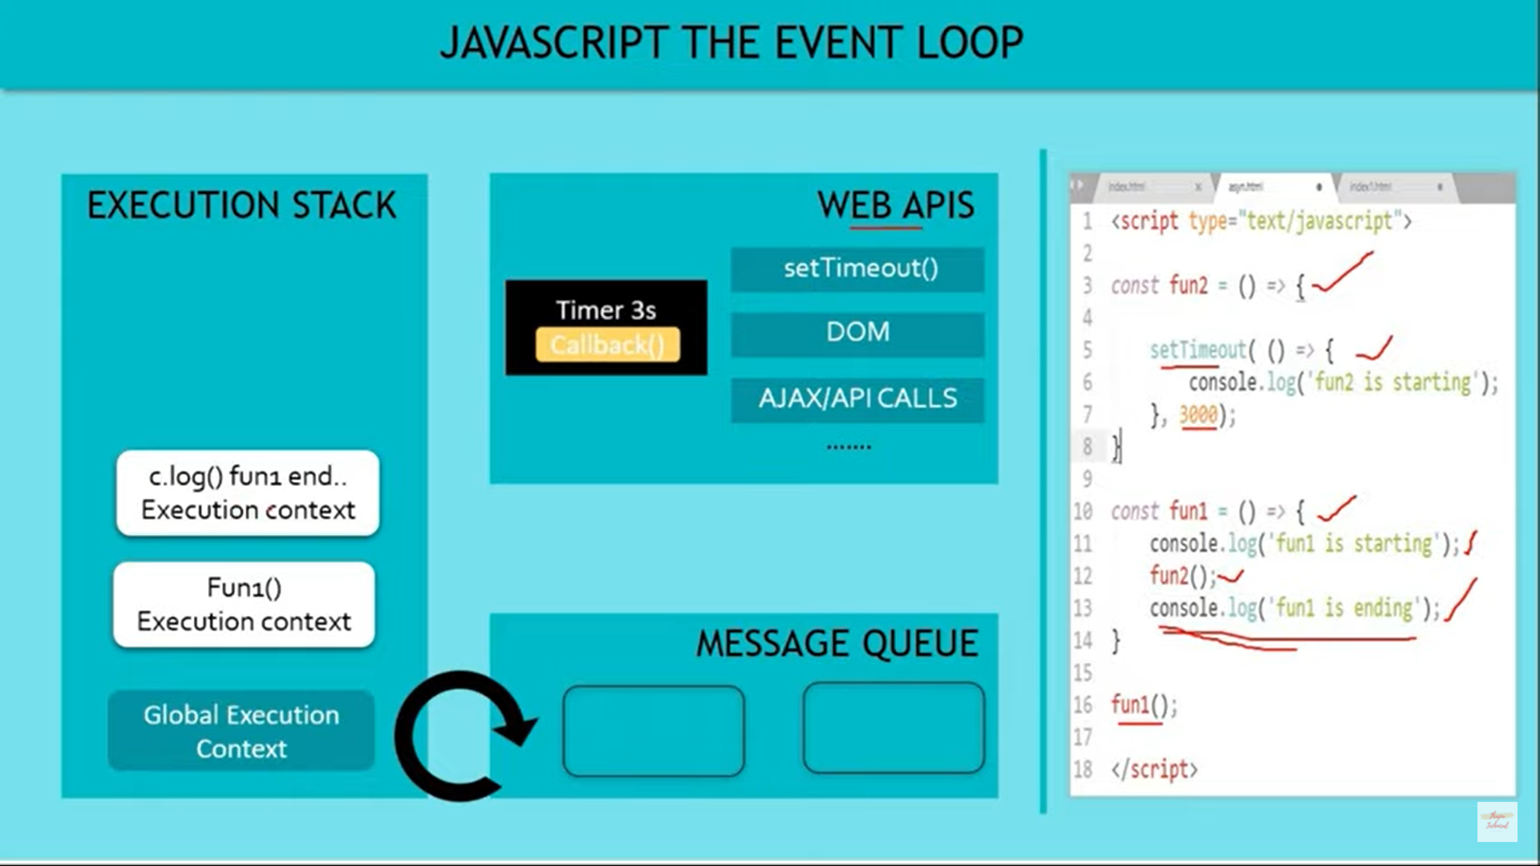

s 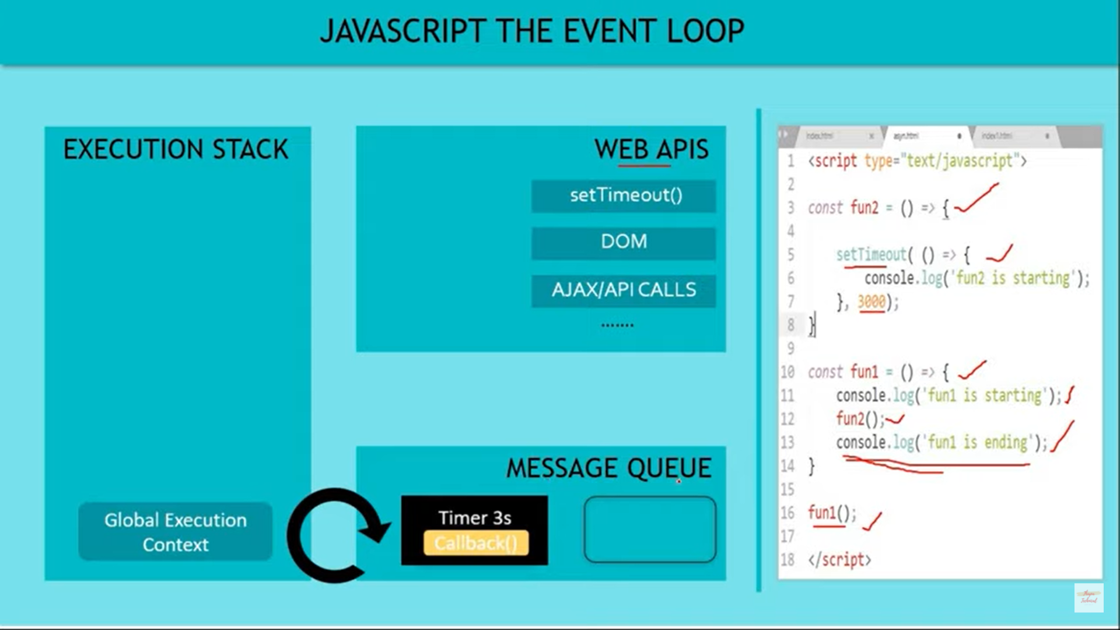

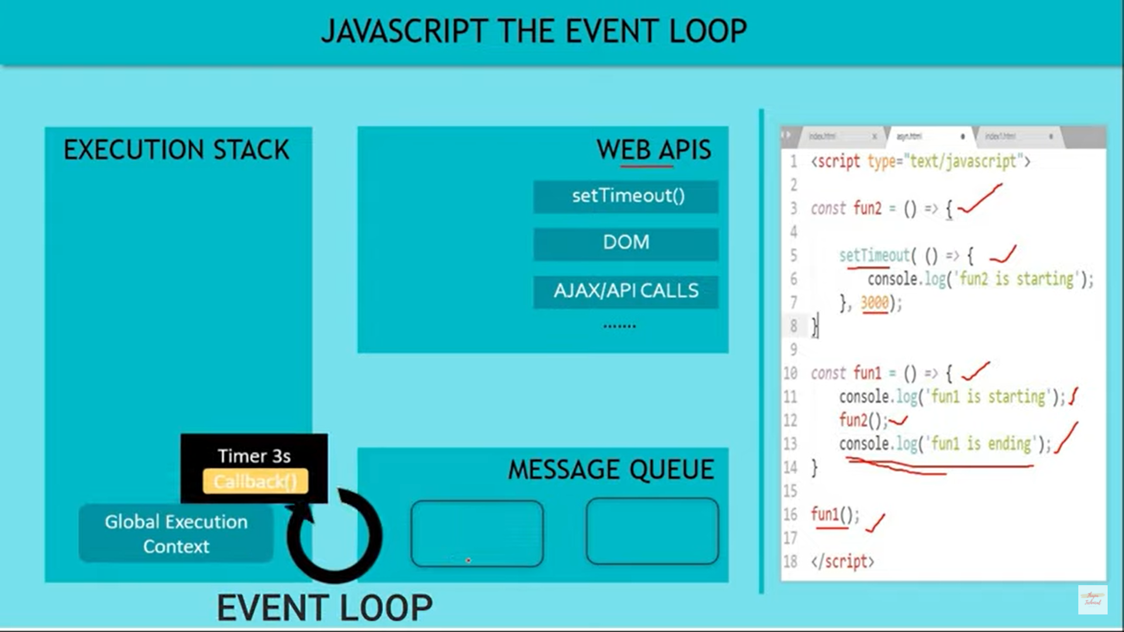

Event Loop checks of there is something on message queue and puts it in execution context